Activating Creative Talent CIC Presents:
Artist Management Factory: Employability Programme
Activating Creating Talent CIC has developed a new employability programme called The Artist Management Factory or AMF©. AMF is a music label and events management ‘tool’, which enables young people to learn about self-management, by facilitating the management of local music and alternative artists. Young Adults are recruited onto the AMF© programme for a minimum period of 12 weeks, where they are tasked with becoming board members of a music label and events management company. Participants individually and collectively have to manage the artists to ultimately prepare and execute an end product i.e. shows or exhibitions.
This programme will motivate, inspire, and give participants the tools to break down barriers to employment. This programme is a 12-week programme delivered 2 days a week on a Tuesday and Wednesdays. This course is completely free for those unemployed, but spaces are limited, so make sure you complete the expression of interest form and get it back to us asap (contact us for details of next enrolment day). We will support participants with travel.
We have an on-going enrolment from 23rd September:
at
Activating Creative Talent CIC
77 Paradise Circus
Queensway
Birmingham
B1 2DT
Tel: 0787 42 46 756
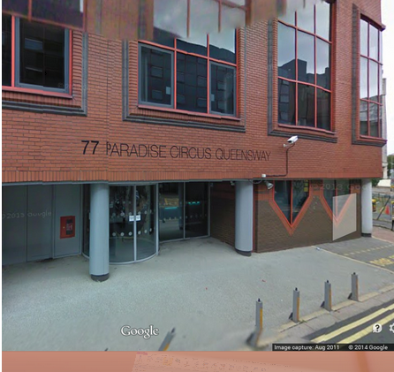

Please complete and return your Application form (see below) via email or contact us to confirm your attendance.

The Next Course Starts on: 30th September 2014
PLEASE MAKE SURE YOUR BRING 1 FORM OF ID EITHER
Passport
Driving license
National Insurance No
Bank card or Debit Card
Certificate of entitlements
Proof of JSA

Artist Management Factory: Employability Programme
Application Form
Name: ……………………………………………………………………..…...........................
Address: ……………………………………….…..………..........................................
……………………………………………………………………………………….…..…
…………………………………………………………………………………..………..…
Email: ....................................................................................................................................
Contact No..............................................................................................................................
Age: …….… D.O.B....................... Gender...........................
Ethnicity ….…………………….…………
NI No …………………………… Benefits Received ………………………………..............
Emergency Contact Details
Name ………………………............................................................................
Relationship...................................................................................................
Address...........................................................................................................
…………………………… …………………………………………………………….
Contact number: ………….. ……………………………………………...............
Doctors Contact Details
Name: ………………………………………………………….................................
Address: ……………………………………………………………….

Contact No:.................................................................................................

Please provide details of any health issues

..........................................................................................................................................................................................................................................................................

All data will be kept by Activating Creative Talent CIC who have an active data protection policy enforce, which promises to keep your data safe and is accessible to you

Please return to admin@alkhami.co.uk
Contact Numbers: 0121 356 1944 or 0787 42 46 756

